Caseloads and Competent Representation: The Ethical Challenge for Government Attorneys of Large Caseloads and Limited Resources

Myles V. Lynk
Senior Assistant Disciplinary Counsel
District of Columbia Office of Disciplinary Counsel

HLSA-DC Panel on Ethics for the Government Attorney
February 25, 2020

The Issue
- How are caseloads for criminal prosecutors and civil attorneys in your Office allocated and determined?
- For example, lawyers responsible for complex felony prosecutions and complex civil proceedings presumably handle fewer cases at one time than lawyers handling misdemeanors and comparable civil cases.
- Do too few lawyers or other resource limitations (e.g., too few investigators, paralegals, online capability, support staff) affect the ability of lawyers in your office to do their jobs?
- Has the issue of large caseloads, leading to an excessive workload in violation of Model Rule of Professional Conduct 1.3, been raised in your Office?
- If so, how was it resolved?

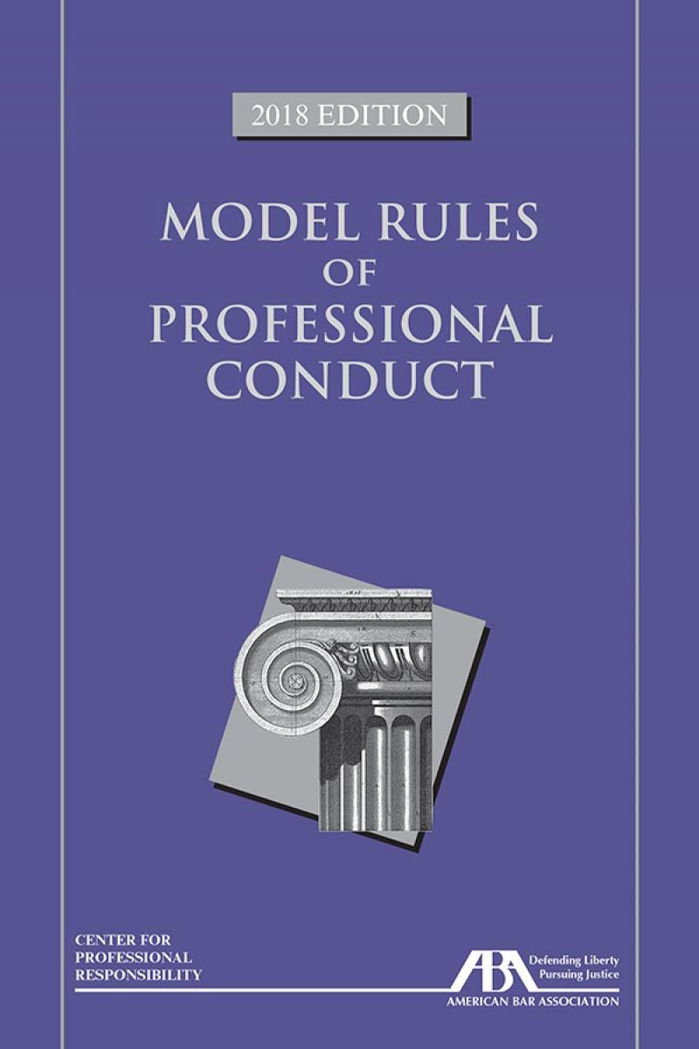
  - Model Rule 1.1: “A lawyer shall provide competent representation to a client. Competent representation requires the legal knowledge, skill, thoroughness and preparation reasonably necessary for the representation.”

  - Comment [5] to Rule 1.1: “Competent handling of a particular matter . . . includes adequate preparation.”

  - Model Rule 1.3: “A lawyer shall act with reasonable diligence and promptness when representing a client.”

  - Comment [2] to MR 1.3: “A lawyer’s workload must be controlled so that each matter can be handled competently.”

  - (Note: “Caseload” can determine “workload,” but the terms may not be synonymous.)

  - Model Rule 1.13(b): Unless the lawyer reasonably believes it is not necessary in the best interests of the organization to do so, the lawyer shall refer the matter [regarding a violation of a legal obligation of the organization or a violation of law by the organization] to higher authority in the organization, including, if warranted by the circumstances, to the highest authority that can act on behalf of the organization as determined by applicable law.”

  - Model Rule 1.16(a): “Except as stated in paragraph (c) [lawyer must obtain permission from the tribunal when terminating a representation in a matter which is before that tribunal], a lawyer shall not represent a client, or where representation has commenced, shall withdraw from the representation of a client if: (1) the representation will result in a violation of the Rules of Professional Conduct.”

  - Model Rule 5.1(a): “A partner in a law firm, and a lawyer who individually or together with others possesses comparable managerial authority in a law firm, shall make reasonable efforts to ensure that the firm has in effect measures giving reasonable assurance that all lawyers in the firm conform to the Rules of Professional Conduct.”

  - Model Rule 5.1(c): “A lawyer shall be responsible for another lawyer’s violation of the Rules of Professional Conduct if: (1) the lawyer orders or, with knowledge of the specific conduct, ratifies the conduct involved;”

  - (The term “law firm” is defined in Rule 1.0(c) to include “lawyers employed in . . . the legal department of a corporation or other organization.”)

  - Model Rule 5.2(b): “ A subordinate lawyer does not violate the Rules of Professional Conduct if that lawyer acts in accordance with a supervisory lawyer’s reasonable resolution of an arguable question of professional duty.” (Emphasis added.)

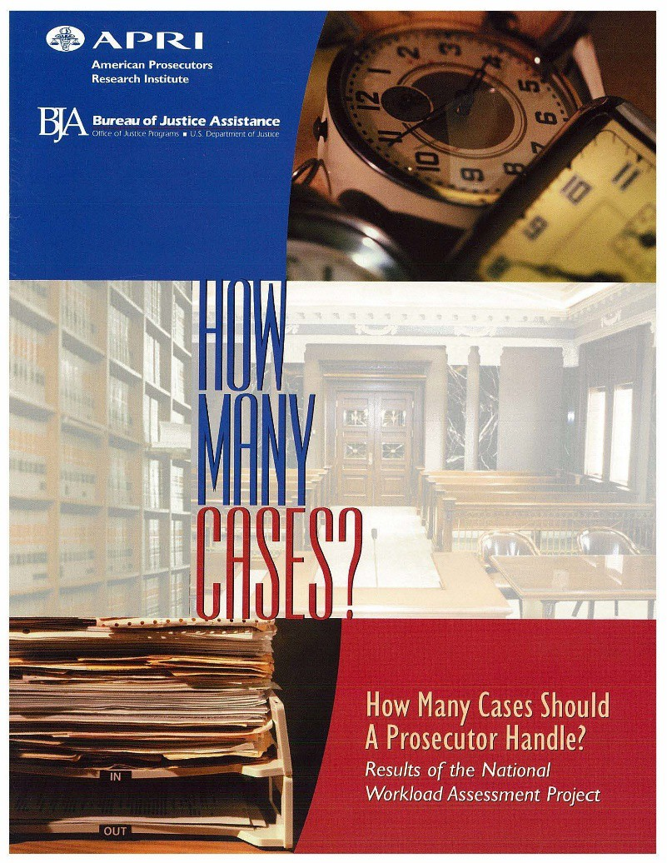
  - 1973 – National Advisory Commission on Criminal Justice Standards and Goals proposed maximum caseload standards for public defenders but not for prosecutors.

  - 2002 – American Prosecutors Research Institute Report, “How Many Cases Should a Prosecutor Handle?” Results of the National Workload Assessment Project, determined that it was not
possible to set national maximum caseload
standards for prosecutors but each state and county could set such standards locally.

  - 2011 – Gershowitz & Killinger, The State (Never) Rests: How Excessive Prosecutorial Caseloads Harm Criminal Defendants, 105 Northwestern Univ. L. Rev. 261 (2011):
  - “[E]xcessive caseloads harm crime victims, who feel ignored by busy prosecutors, and the public at large, which is disserved when overwhelmed prosecutors lack the time and resources to handle cases against clearly guilty defendants.”
  - “[O]verburdening prosecutors results in longer sentences for less culpable offenders, longer delays in the dismissal of charges . . ., fewer disclosures of exculpatory evidence by prosecutors, and more guilty pleas by innocent defendants in exchange for sentences of time served and release from jail.”

  - 2018 – Peter Joy, “Overloaded Prosecutors,” 33 Criminal Justice 31 (Summer 2018):

    - “The most important legal and ethical mandate for prosecutors is to seek a just resolution of a criminal case [O]verloaded
prosecutors are much less likely to be able to fulfill this mandate.”

  - Yes! E.g., Are Commonwealth Attorneys Held to the Same Ethical Requirements as Other Attorneys?, Virginia Legal Ethics Opinion 1798 (2004)
(In hypothetical cases where a Commonwealth’s
Attorney’s office was understaffed, the Assistant Commonwealth’s Attorney to whom two cases were assigned, missed deadlines and did not interview witnesses as a direct result of his heavy
caseload, resulting in both cases being dismissed. The Ethics Committee
concluded the attorney had violated Rules 1.1 and 1.3. “The language of Rules 1.1 and 1.3 include no exceptions; there is no language creating a different standard for prosecutors.”)

  - What should the attorney have done? The Virginia State Bar’s Ethics Committee opined:
  - “Any attorney serving as a Commonwealth’s Attorney, in fulfilling his duties of competence and diligence, must be mindful of a pertinent directive from Rule 1.16. Paragraph (a) of Rule 1.16 dictates that a lawyer not accept or continue a particular representation if it means violating another ethics rule.”

  - The Virginia Bar’s Legal Ethics Committee also quoted approvingly the following language from the Arizona State Bar’s Ethics Opinion 86-4:

  - “[Where the demands of an extreme caseload make an attorney unable to devote sufficient attention to a particular case, acceptance of that case will cause a violation of Ethical Rules 1.1 on competent representation, 1.3 on attorney diligence and 1.16 for failing to decline or terminate representation when the representation will violate these rules.”

What Are the Factors That Cause Large Caseloads Leading to Excessive Workloads?

  - Budget Constraints – State legislatures and county officials faced with many conflicting demands may not allocate necessary funds to increase the personnel and other resources available to Attorneys General’s Offices and local prosecutors.
  - Whether elected or appointed, Attorneys General and District Attorneys may see high caseloads as good public relations; it shows their office is working hard. And they may not want to risk alienating legislators b pressing for more funds and being accused of wanting to raise taxes.
  - Unlike public defenders, line government attorneys are not likely to file suit alleging that their workloads are excessive. Setting aside the fact that such a move would likely end their government careers, they would lack the requisites of a case and controversy; their clients have no 6th and 14th Amendment claims as indigent defendants would have.

  - In its Ethics Advisory Opinion 04-12 (2004) addressed to a public defender’s ethical obligations if the attorney is asked to carry an excessive caseload, the South Carolina Bar Ethics Advisory Committee laid out a number of steps the attorney could take.

  - Could these steps also be used by government attorneys in similar situations?
  - 1. In evaluating the ethical aspects of their caseloads, consult with other lawyers in the office and experts on professional ethics, and “consider the extent to which the caseload is producing a level of stress that makes the attorney feel that his or her work is out of control.”

  - 2. “If the attorney concludes, based on an analysis of these and other factors that the attorney’s caseload is resulting or is likely to result in ethical violations, the attorney is ethically required to take appropriate steps to deal with the situation.”

  - 3. Initially, the attorney should raise the matter with her or his direct supervisor or other senior attorney, depending on the organization of the office, in light of their responsibility under Rule 5.1 to take reasonable steps to ensure that the attorneys in the office are practicing in accordance with the Rules of Professional Conduct.

  - 4. If the attorney does not receive an ethically satisfactory response that is a reasonable resolution of an arguable question of professional duty within the meaning of Rule 5.2(b), the attorney must consider additional steps, including bringing the matter to the attention of the Attorney General or District Attorney, pursuant to Rule 1.13(b).

  - 5. “At a certain point the attorney must refuse to accept further assignments until the attorney’s caseload is reduced to a level that does not present ethical problems. In some situations, the attorney may need to consider seeking to withdraw from representation of some clients under Rule 1.16(a)(1).”

Are these steps realistic in the context of your Office?

  - If not, are there other steps that you and your colleagues can take to address this issue if it is present in your Office?

DISCUSSION

